Course Project - Topic Selection

Shaun Pritchard

Rasmussen College

QMB4100

Darice Corey

April 11, 2021

**History of Allrecipes.com**:

Allrecipes.com, claims to be the world’s #1 food brand in helping home cooks around the globe discover and share the joy of cooking. They claim their platform can facilitate this through community-driven content, products, and services. They also claim their platform utilized data and trends to combining digital insights and editorial expertise, Allrecipes.com serves as a digital and conceptual magazine as 3well as a social media platform for cooks and creators to implement recipes. They help cooks globally get recipes recognized and reviewed with a start system. All recipes.com is a subsidiary company owned by Meredith Corporation (Meredith, 2021).

Meredith is a publicly held multinational global media and marketing company whose media services media and marketing capabilities are focused on content creations, digital media, video, regeneration, research, predictive intelligence, content licensing, creative services, print production, and target marketing. Meredith claims their founded upon serving their customers and committed to building value for our shareholders.

Allrecipes.com was founded and based in Seattle Washington in 1997 after the co-founders Tim Hunt and Carl Shepherd had trouble finding their favorite cookie recipes on the Internet in 1997. Since 1997, Allrecipes.com has grown and evolved into a new social web application that not only offers a directory for recipes but a social network where cooks and creators across the globe can upload, share, and rate recipes. It is now the world's biggest online food community but the world's biggest food-focused social community. Allrecipes.com sends users recipe ideas and step-by-step instructions, along with Amazon-style, context-appropriate ads. If you register on the site, Allrecipes.com stores personal information like eating preferences, food allergies, shopping habits, so nearby supermarkets can target you with weekly specials. Also, Allrecipes.com implements engaging visuals, personalized "cooking graphs," and an "I Made This" button that celebrates users' favorite foods (Holden, 2015).

**Product or service idea**

This product and service idea will be based globally being launched on the Allrecipes.com web. It would require the adaptability to be translated for multiple languages, web, and mobile platforms. The product service will facilitate the implementation of custom pre-defined meal plans based on health and budget factors determined by the user. This would be a feature service that would be customizable from within the user account space. Allowing them to select options and have a daily, monthly, and yearly defined meal plan for each day of the week for every meal utilizing top recommendations recipes and foods to better their health, intrigue their senses, helping them save time and money.

This would give exposure to creators of recipes, social recipes, and trends, contingent on custom user experience per user and within the community of allrecipes.com. These meal plans would be a great opportunity to strengthen digital marketing efforts, upsells, and advertisements for individual products and recommendations and ingredients.

This service could also act as a channel to let more custom recipes get more exposure and ratings that could increase revenue streams. Using Machine learning and data analytics systems would also prove to harness the usability of user data. capturing more insights on personal user patterns, engagements, behaviors, interests, and demographics. That in turn could be used to target the market to customers and create a better experience for all users. Also, partnerships and additional services and ad vendors would be attracted to possible opportunities through this venture.

**Best data source of analytics:**

I was able to acquire several sources of viable data to determine analytics based on given factors that would contribute the new product or service of custom pre-defined meal plans for individual users and social communities in the all recipes platform. Allrecipes.com brings in data from Adobe Marketing Cloud and demographic information from comScore and Hitwise. Because of this I had to use some out of the box thinking to acquire sources of data.

* Kaggle – datasets collected of recipe, food ingredients, ratings, cooking directions, nutritional facts, and reviews (foodRecSys-V1, 2021).
* Python Web scraper – using python script I will be able to scrape and resolve updated data and features for recipes and categories on allrecipes.com (Pritchard, 2021).
* Google Dataset Search – This resource allowed me to find multiple sources of data online from sources such as datahub.io, figshare.com, Kaggle, and many others (Google, 2021).

**Possible problems or business opportunities:**

**Opportunities:**

The opportunities given this new product facilitate an advantageous edge to the recipe and social media industry. Currently, there are no social media or community-based platform switch that give people opportunities to customize meals. Especially meal plans based on top custom 5 Star recipes that are uniquely designed and selected to meet specific dietary requirements and budget constraints.

This was product could facilitate the opportunity for the Allrecipes.com company to collect more data on customers and users to custom tailor their experience achieving something that has not been done. This would be a platform service that allows user feedback and data to contribute to predefined meal plans offers opportunities to new cooks and creators to get their dishes to more consumers. It offers the opportunity to implement a stronger advertising platform which could increase revenue and market share exponentially. We can see trends in other tech companies such as Facebook that increased after adding their ad and video platform in 2007 to 2014 (Macrotrends , 2021). giving users the ability to customize their experiences. We can also see using Google trends that Meal plans are searched for 50% more than health recipes (Gogole Trends, 2021). This category on Allrecipes.com is a current driving revenue factor. Implementing these services could double potential earnings and market shares.

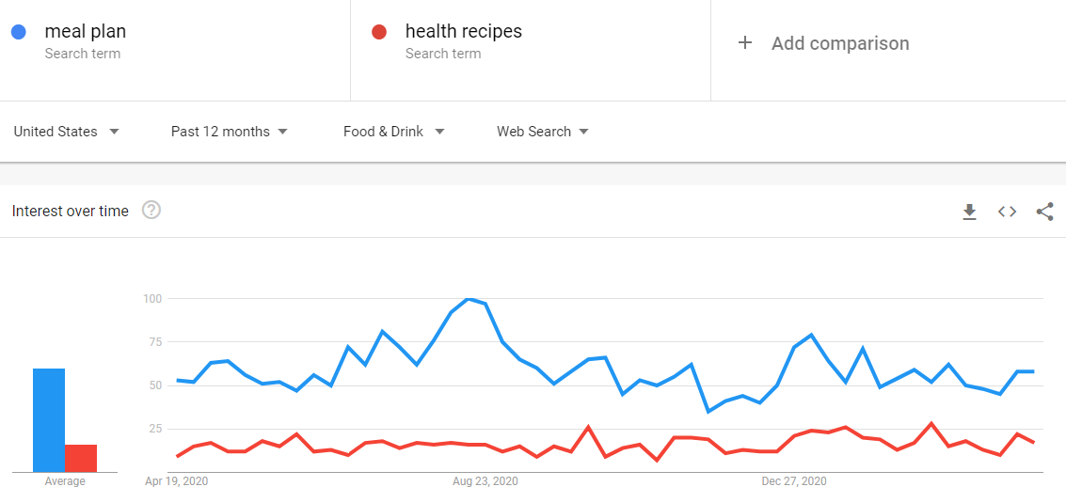

**Problems:**

The issues as it stands facilitates the allrecipes.com infrastructure such as data allocations, time, resources to feasibly implement and design the service. New backend services and database clusters will need to be allocated and scoped for incoming usage the undertaking of frontend and backend development will need to be scoped out and implemented and tested as a new in-app feature for both web and mobile devices. This might require building or adding logic to an API(Application Interface). Also, marketing and distribution plans for pre- and post-launch will have to be developed and executed on schedule. While these are feasible actions to take the resources and planning pose constraints. I would recommend a case study and A&B testing of this concept also a marketing effort survey to test the community factor to see if a viable feature would be the Allrecipes.com communities would embrace.

**Stakeholders interest and an effect on the business:**

**External Stakeholders:**

External stakeholders are groups outside a business or people who do not work inside the business but are affected in some way by the decisions and actions of the business. The stakeholder below has an interest and an effect on the business as follows.

* **Shareholders** - New features and user experience that gain traction means more users and more revenue streams. This would prove to be a positive motivation for all shareholders to stimulate market viability and evaluation through new initiatives.
* **Customers** - New features would enhance the overall customer-base and user experience. New features cause great interest and more through customized features and services such as ready-made meal plans that are adjusted to user’s health requirements and budgets. Other customers such as advertisers, content creators, and recipe inventors would benefit from more exposer and faster more frequent ratings to their creations.

**Internal stakeholders:**

are groups of people who work directly within the business, such as managers, employees, and owners. The stakeholder below has an interest and an effect on the business as follows.

* **Owners** - interest to the owners would facilitate the new scope of enhancing and evolving the applications and media platforms. This would prove to be a positive motivation for all shareholders to stimulate market viability and evaluation through new initiatives.
* **Employees** - inevitably this venture would lead to more work which would mean more consistency and viability of employment with an innovative growing company.

**3-Stakeholders’ needs and possible opportunities**.

* **Shareholders** - the shareholders invest in companies for market share growth innovating new solutions that could attribute to are always applicable opportunities and needs for shareholders. Implementing a new user experience that could evolve the platform and retain more user attention would facilitate this goal. Essentliy, providing more opportunities for the company and the shareholders in itself. Having predefined meal plans based on metrics defined by user’s health requirements and budget constraints would give the company more insight into the user’s behaviors, interest, needs, and likes of the platform. Therefore, more data allocation, new algorithms can be implemented into the platform facilitating the new creations in recipes giving creators more exposure to their works and ideas. Which would intern mean more creators would be attracted to this platform therefor more engagement, and more revenue. This concept would initiate Innovation and growth that would exponentially increase market shares. This could also lead to opportunities with expanding advertising partnerships with other digital media services such as food and ingredient sales both online and offline, coupons and discounts food, equipment, and related services to make the pre-planned meals. This could also be a viable avenue to open up opportunities in the health industry and physical training space. Brining their influence to recommend meals and plans that would expand the user base even more while opening up doors to new sources of revenue streams and new trends.
* **Customers/users** - opportunities to have a more custom define user experience on a platform that allows them to custom design meal plans weekly, monthly, and yearly that they can follow for their health requirements and financial constraints. This is something that is highly sought and viable market. There is meal planning API's and resources that already exist in reference to partners, distributors, and advertisers for meal planning and food products such as Amazon, Walmart, and other food and supply distributors. Having customizable access to this initiative would be advantageous for a growing Community platform that would attract more customers and users.
* **Society** - this could be an innovation that contributes to many societies through newly defined service such as custom predefined meal plans that could help local economies grow and be more mindful of eating choices while having access to experiencing new recipes and creations that could benefit families and businesses across the globe.

# References

foodRecSys-V1. (2021). Retrieved from https://www.kaggle.com/: https://www.kaggle.com/elisaxxygao/foodrecsysv1

*Gogole Trends*. (2021). Retrieved from https://trends.google.com: https://trends.google.com/trends/explore?geo=US&q=meal%20plans,health%20recipes

Google. (2021). *Allrecipes.com dataset*. Retrieved from https://datasetsearch.research.google.com/: https://datasetsearch.research.google.com/search?query=allrecipe.com&docid=HHQ032mqKGF0pDwEAAAAAA%3D%3D

Holden, R. (2015, Sep 1). *Seattle-based allrecipes.Com rebrands as a social network*. Retrieved from https://seattle.eater.com: https://seattle.eater.com/2015/9/1/9239945/seattle-based-allrecipes-com-rebrands-as-a-social-network

Macrotrends . (2021). *Facebook - Stock Price History | FB*. Retrieved from https://www.macrotrends.net: https://www.macrotrends.net/stocks/charts/FB/facebook/stock-price-history

Meredith. (2021). *Allrecipes | Meredith*. Retrieved from https://www.meredith.com: https://www.meredith.com/brand/allrecipes

Pritchard, S. (2021). *Recipe-scrapers*. Retrieved from https://github.com/shaungt1/recipe-scrapers: https://github.com/hhursev/recipe-scrapers